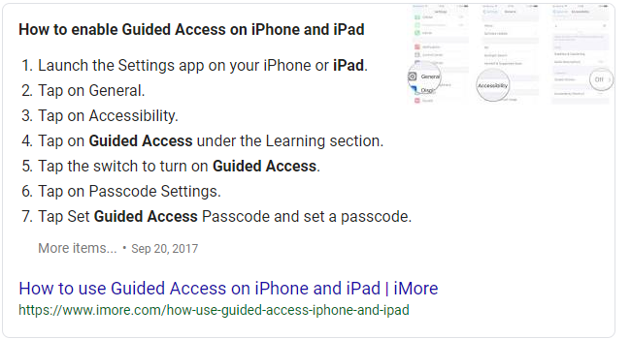

How to use it:
Open the app you want the student to use.
Triple click
A screen will pop up
Click Start
It will say guided access started
To take it off
Triple click and put in the password
End

