SAGE Login for Labs
1. Login with SAGE password SAGE!
2. Look for the icon
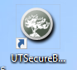
3. If you are doing the training test click on the Red Arrow by the bike.
4. If you are doing the real test, stay on this page to login.
5. Click on close secure browser when finished.

